

A Report on the Course Project of

**Engineering Exploration (15ECRP101)**

**titled**

**Marble Rumble**

By

|  |  |
| --- | --- |
| Gayatri.A.Betageri | 723 |
| Nitish Panchagavi | 768 |
| |  | | --- | | Vivek Yeli | | 712 |
| Siddharth Hattiholi | 730 |
|  |  |

Under the guidance of

**RADHIKA AMASHI Mtech**

**ASSISTANT PROFESSOR**

Centre for Engineering Education Research

Academic Year 2021-2022, Even Semester



Centre for Engineering Education Research

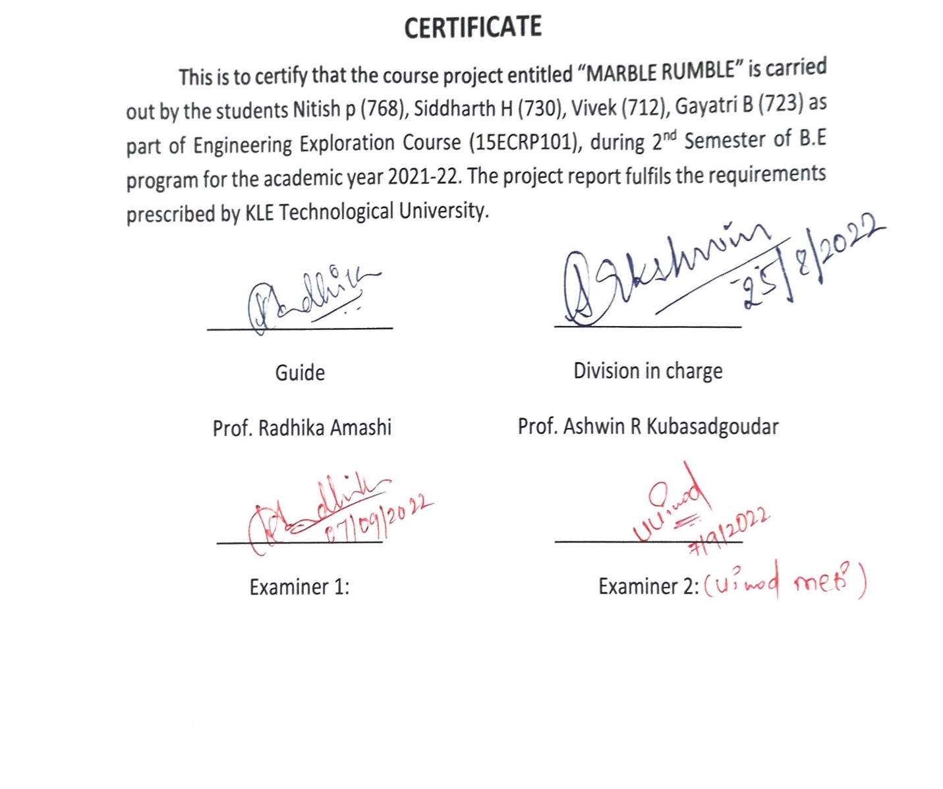

### DECLARATION

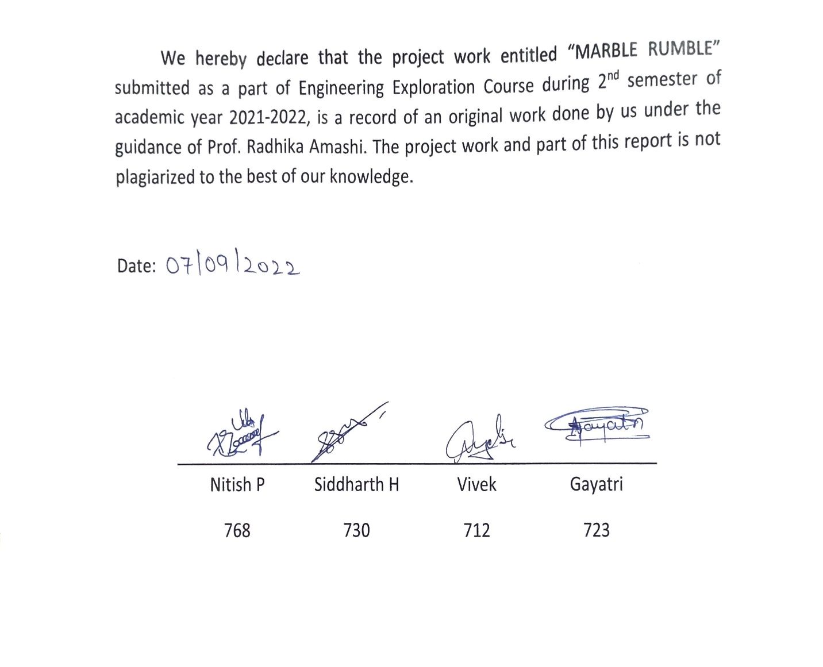

**ACKNOWLEDGEMENT**

The pleasure that follows the successful completion of our exploration course project, titled “MARBLE RUMBLE” would remain incomplete without a word of gratitude to every single person who has contributed help for the completion of our course project.

We are grateful to have as our guide Prof. Radhika Amashi and also would like to extend our gratitude to our Co-Guides Prof. Ashwin R. KhubasadGoudar, Prof. Shivprasad .Channangi and Dr. Preeti .Patil and express our sincere gratitude for their motivation, inspiration, guidance, and support during the completion of the project. Their words of encouragement and unconditional dedication will always be cherished.

We extend our sincere gratitude towards our respected HOD Dr. Vijayalakshmi. M, Department of Centre for Engineering Education and Research, KLE Technological University for providing us the opportunity to carry out the project and bestowing us a well-equipped laboratory for the conduction of our course project.

We also thank our Vice-chancellor Dr. Ashok S. Shettar and also our registrar Dr. N. H. Ayachit for his valuable support and their help in providing the infrastructure.

We are thankful to our CEER department for providing all the necessary materials for our project. We also thank all the non-teaching staff, lab instructors, and lab associates who helped us throughout the project.

We are obliged to all those who have helped us in the successful completion of our Engineering Exploration course project for the academic year 2021-2022.

Last but not the least we thank our parents for their constant support and intellect opinions that kept us motivated and dedicated towards the project

**ABSTRACT:**

The use of marble bots is gaining lot of importance in the field of gaming industry. The present work intends to design & build a marble run bot named “Marble Rumble”, which is capable of performing some basic mechanism. An initial survey was performed to gather clients’ requirements in terms of functionalities and constraints. Considering the functional requirements, constraints and client’s objectives, a problem definition was refined to perform the Cam mechanism.Function tree was designed to get the sequential functions to be performed by the model. Morphological chart was prepared considering all possible elements /subsystems/variables which help to make proper decisions in each scenario. Further, four different conceptual design models were established using the inputs from the morphological chart. The best possible design was considered for further fabrication with the Pugh chart analysis by assigning proper weightages for important design objectives. Functional clustering using function tree was performed leading to the identification of three different sub-systems such as locomotory and navigation unit, indication unit and sensory unit. Analysis of interaction between the subsystems was analysed and was helpful in the fabrication of the working model. Virtual Implementation of the designed model was performed using “Autodesk Inventor” 3-D modelling software. The virtual circuits were built using circuito.io website. The flowcharts were prepared to gain the deeper understanding of sequence of operations to be performed by the physical model. As per the design specifications, Torque required was calculated which acts as an input for the selection of suitable type of motors for the model, suitable adapter was chosen (2A @12V adapter) based on the power requirement calculated for the model. All the model units/components were assembled and was tested for all the functional aspects. The model “Marble Rumble” was found to be working satisfactorily as per the design specifications specified in the objectives. Therefore, we intended to build a model which the machine mainly makes use of the cam mechanism, an IR sensor which senses the marble after one lap and this machine also gives a buzzer after the marble completes its one lap. This machine makes use of the power supply and initially it involves an individual to add /place a marble at the beginning of the track. After which the marble continues to move on the path or on the track thereby with the up and down movement of the cams.

This project of marble run mainly helps to improve the focus and concentration and hand-eye co-ordination i.e from fitting the individual pieces of the track together to dropping the marble in just the right spot thereby encouraging creativity.

Table of Contents:

|  |  |
| --- | --- |
| List of Figures | **i** |
| List of Tables | **ii** |
| 1. Problem Definition | **1** |
| * 1. Need Statement | **1** |
| * 1. Literature Survey | **1** |
| * 1. Questions asked to client / users for arriving at Objectives, Functions and Constraints | **7** |
| * 1. Objectives | **8** |
| * 1. Constraints | **8** |
| * 1. Functions | **9** |
| 1. Conceptual Design | **10** |
| * 1. Establishing Functions | **10** |
| * 1. Functions Tree | **11** |
| * 1. Morphological Chart | **12** |
| * 1. Generated Concepts | **13** |
| 1. Conceptual Evaluation and Product Architecture | **14** |
| * 1. Pugh Chart | **14** |
| * 1. Justification for the Scores | **15** |
| * 1. Selected Design | **17** |
| * 1. Product Architecture      1. Function Clustering | **18** |
| * + 1. Interaction between subsystems | **19** |
| 1. Implementation    1. Sprint 1 Implementation       1. 3D model of the sprint 1 | **20**  20 |
| * + 1. Bill of Materials (BOM) of the sprint 1 | **20** |
| * + 1. Circuit diagram of the sprint 1 | **-** |
| * + 1. Flow chart of the sprint 1 | **21** |
| * + 1. Physical implementation image of the sprint 1 | **22** |
| * 1. Sprint 2 Implementation      1. 3D model of the sprint 2 | **23** |
| * + 1. Bill of Materials (BOM) of the sprint 2 | **25** |
| * + 1. Circuit diagram of the sprint 2 | **25** |
| * + 1. Flow chart of the sprint 2 | **26** |
| * + 1. Physical implementation image of the sprint 2 | **27** |

|  |  |
| --- | --- |
| * 1. Motor and Resource Specification | **29** |
| 1. Statement of Expenditure | **30** |
| 1. Limitations of Present work and Future Scope | **31** |
| 1. References | **31** |

|  |
| --- |
|  |
|  |
|  |

**List of Figures**

|  |  |  |
| --- | --- | --- |
| Fig. 1 | BIG MARBLE RUN MACHINE | 04 |
| Fig. 2 | ROLLING BALL CLOCK WITH STEEL BALLS | 05 |
| Fig. 3 | AUTOMATIC MARBLE RUN MACHINE | 05 |
| Fig. 4 | MINI GOLF MARBLE MACHINE | 06 |
| Fig. 5 | MARBLE CLIMBING MACHINE | 06 |
| Fig. 6 | FUNCTION TREE | 11 |
| Fig.7 | MORPHOLOGICAL CHART | 12 |
| Fig.8 | MARBLE RUN MACHINE | 13 |
| Fig. 9 | MARBLE CLIMBING MACHINE | 13 |
| Fig. 10 | AUTOMATIC MARBLE RUN MACHINE | 14 |
| Fig. 11 | AUTOMATED MARBLE RUN MACHINE | 14 |
| Fig. 12 | MARBLE CLIMBING MACHINE | 18 |
| Fig. 13 | FUNCTION CLUSTERING | 19 |
| Fig. 14 | 3D MODEL SPRINT 1 | 20 |
| Fig.15 | FLOW CHART SPRINT 1 | 21 |
| Fig.16  Fig.17  Fig.18  Fig.19  Fig.20 | PHYSICAL IMPLEMENTATION SPRINT 1  3D MODEL SPRINT 2  CIRCUIT DIAGRAM  FLOW CHART SPRINT 2  PHYSICAL IMPLEMENTATION SPRINT 2 | 22  23  25  26  27 |

**List of Tables**

|  |  |  |
| --- | --- | --- |
| Table. 1 | INTRODUCTION | 02 |
| Table. 2 | QUESTION AND ANSWERS WITH CLIENT | 07 |
| Table. 3 | OBJECTIVES | 08 |
| Table. 4 | CONSTRAINTS | 08 |
| Table. 5 | FUNCTIONS | 09 |
| Table. 6 | ESTABLISHING FUNCTIONS | 10 |
| Table.7 | MORPOLOGICAL CHART | 12 |
| Table.8 | PUGH CHART | 14 |
| Table.9 | JUSTIFICATION OF SCORES | 15 |
| Table.10 | INTERACTION BETWEEN SUBSYSTEMS | 19 |
| Table.11 | BILL OF MATERIALS SPRINT 1 | 20 |
| Table.12 | BILL OF MATERIALS SPRINT 2 | 25 |
| Table.13 | STATEMENT OF EXPENDITURE | 29 |
|  |  |  |

**1. Problem Definition**

**1.1. Need Statement**

Design a semi-automatic/automatic marble running machine with an aesthetic look being user friendly, portable and which must be played using marbles. The build quality of the machine should be durable. The machine should be of size 1*1*1feet , the budget must be under rupees 3000.There should be stable movement and restoration of the marbles.

**1.2. Gathering Pertinent Information**

# ****NEED STATEMENT****:

## MARBLE RUNNING MACHINE

AB industry is in need of designing a machine which help in flowing the marbles. This machine acts as a game machine for all kinds of users to improve the focus and concentration.

### Introduction

A marble run is same like a slide i.e, a marble rolls down the structure. Building a marble run machine is an efficient way to explore the concept of relative position and motion. A marble machine is a creative ball-run contraption, made from familiar materials, designed to send a rolling marble through tubes and funnels, across tracks and bumpers, and into a catch at the end.

In this experiment we have to set up a ramp. A ramp or inclined plane is an example of one of the six types of simple machines. A simple machine allows you to use less force to push or pull an object over a greater distance. When using simple machines, we can also look at the potential and the kinetic energy of the marble. When the marble is at the top of the ramp it has high potential energy, also known as stored energy. As the marble travels down the ramp builds kinetic energy, or energy in motion The marble will have the greatest amount of kinetic energy when it reaches the bottom of the ramp, because it would continue to gain energy as it travels down the ramp. Objects that have different masses usually have different amount of potential and kinetic energy and will also take different times to travel down the ramp.

|  |  |  |  |  |
| --- | --- | --- | --- | --- |
| **SL.NO** | **PROJECT IDEAS** | **FUNCTION/WORKING** | **COMPONENTS** | **LINK** |
| 1 | BIG MARBLE RUN MACHINE | Gravity pulls the marble down. At top, the marble has potential energy as the marble rolls down the potential energy is converted to kinetic energy (energy of motion). | DC Motor, Speed controller DC controller,9v battery, BBQ bamboo sticks, Ice cream sticks, switch, cardboard | <https://youtu.be/uO21ivbLxsc> |
| 2 | ROLLING BALL CLOCK WITH STEEL BALLS | The rolling ball clock has three main rails – two labeled for minutes and one for hours. The bottom rail represents the hours. The middle rail represents the minutes in multiples of 5 or 10 , while the top rail displays the numbers 1 through 4. By adding the displayed values of the two rails one could get an accurate measurement of the minutes. An electric motor scoops up a ball every minute. Every five minutes, the top rail will dump and deposit a ball on the second rail. Every hour, the upper and middle rails dump and one ball is transferred to the bottom rail to increment the hours. | wood, motors, linecords, ballbearings , drill ,DC Motor, Speed controller | <https://www.youtube.com/watch?v=FgrG5Vxkk3U&t=265s> |
| 3 | AUTOMATIC MARBLE RUN MACHINE | Gravity pulls the marble down. At top, the marble has potential energy as the marble rolls down the potential energy is converted to kinetic energy (energy of motion). | Paperboard,Marbles,12V DC motor,4V battery, Switch, Silicone | <https://youtu.be/jQK0QmuzQhE> |
| 4 | MINI GOLF MARBLE MACHINE | With the help of the DC Motor the marbles move from top to bottom. | DC motor, Marbles ,Battery, Switch, Ice cream sticks | <https://youtu.be/8Mmx2M9XfPI> |
| 5 | ELECTRONIC MARBLE MUSIC MACHINE | Electronic marble music machine is engineered to play songs using Arduino to run a computer program that plays song by dropping marbles on musical notes from a glockenspiel. | DC motor, Battery, Switch, Marbles | <https://youtu.be/QeK0jVdvpKg> |
| 6 | MARBLE CLIMBING MACHINE | Cams are used to convert rotary to linear (reciprocating)motion. As the cam rotates, the marbles rises and falls in a process known as reciprocating motion. | DC low speed motor, Hot glue gun, Battery and wire connection | <https://www.youtube.com/watch?v=QcL9sIOzGbs> |

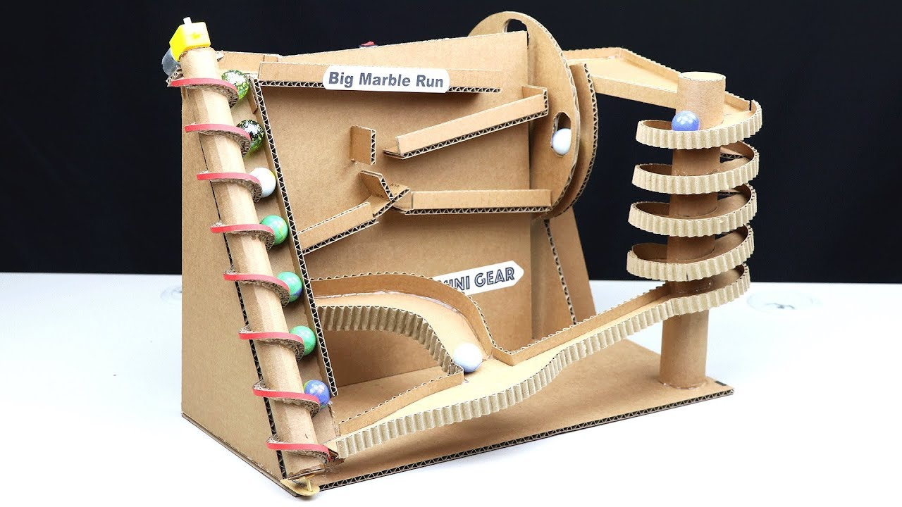

Figure 1:BIG MARBLE RUN MACHINE

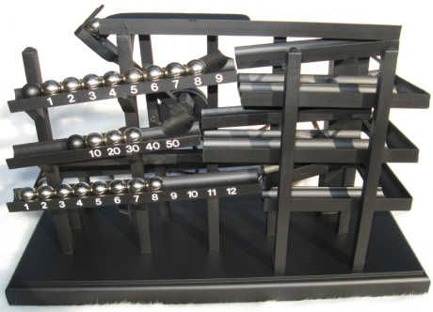

Figure 2:ROLLING BALL CLOCK WITH STEEL BALLS

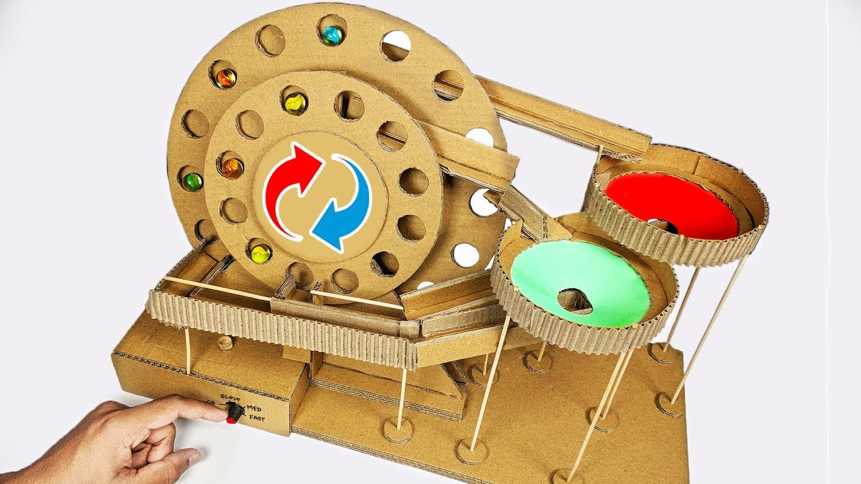

Figure 3:AUTOMATIC MARBLE RUN MACHINE

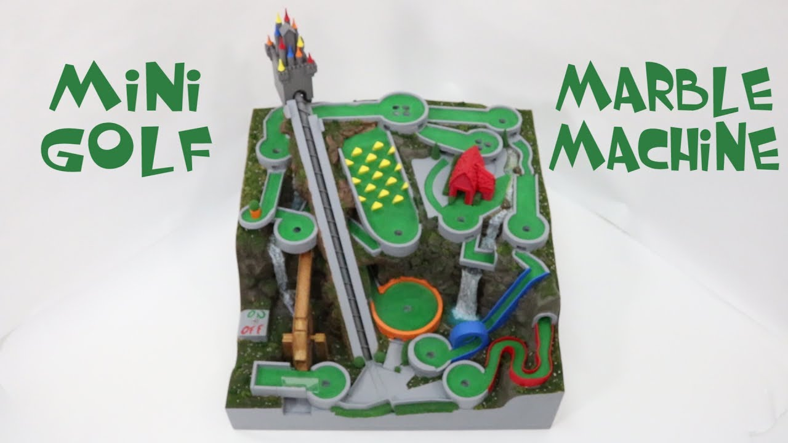

Figure 4:MINI GOLF MARBLE RUN MACHINE

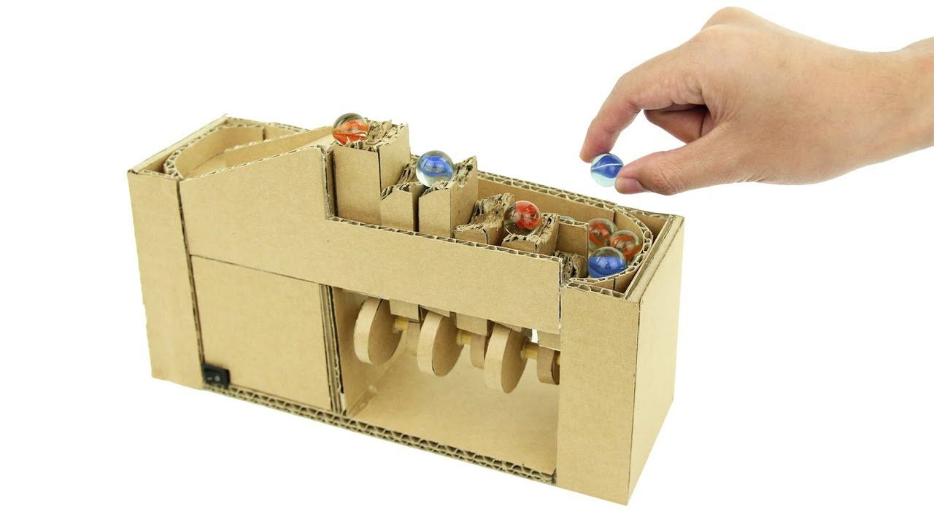

Figure 5:MARBLE CLIMBING MACHINE

1.3. Questions asked to client / users for arriving at Objectives, Functions and Constraints

|  |  |  |  |  |  |
| --- | --- | --- | --- | --- | --- |
| **Sl. No.** | **Questions** | **Answers** | **O** | **C** | **F** |
| **1.** | What is your budget? | 3000 Rupees |  | ✓ |  |
| **2.** | What is time duration to complete the project? | 3 months |  | ✓ |  |
| **3.** | What should be the maximum weight of the model? | Around 1.3kg |  | ✓ |  |
| **4.** | What should be the size of the model? | 1 * 1 * 1 cubic feet |  | ✓ |  |
| **5.** | What materials should be used in making the model? | Cardboard | ✓ |  |  |
| **6.** | The model should be fixed or portable ? | Portable | ✓ |  |  |
| **7.** | What should be the size of the marble? | Diameter 2cm |  | ✓ |  |
| **8.** | How will the model starts its operation ? | When touched |  |  | ✓ |
| **9.** | Model should be automatic or manual? | Automatic and durable | ✓ |  |  |
| **10.** | What should be the main benefit of the model? | Attractive and durable | ✓ |  |  |
| **11.** | Any other specific requirements ? | Buzzer should be added and it should be creative |  |  | ✓ |
| **12.** | How will the ball change its direction? | With the help of navigators |  |  | ✓ |

**1.4. Objectives**

|  |  |
| --- | --- |
| **Sl. No** | **Objectives** |
| **1.** | **It should be aesthetically attractive.** |
| **2.** | **Machine should be automatic / semi-automatic.** |
| **3.** | **It should be portable.** |

**Problem definition 1.1**

Design a semiautomatic/automatic model that is aesthetically attractive, user friendly, portable

**1.5. Constraints**

|  |  |
| --- | --- |
| **Sl. No** | **Constraints** |
| **1.** | **The budget of the model should not exceed 3000 rupees.** |
| **2.** | **The model should be completed within 3 months.** |
| **3.** | **The weight of the model should be around 1-1.5kg.** |
| **4.** | **The size of the model should be 1 cubic feet.** |
| **5.** | **The size of the marble should be of diameter 2cm.** |

# Problem definition 1.2

Design a model that is aesthetically attractive , user friendly , portable and durable .The budget of the model should not exceed 3000 rupees and it should be completed within 3 months . The weight of the model is expected to be 1-1.5 kg and the size of the marble should be of diameter 2cm.

**1.6. Functions**

|  |  |
| --- | --- |
| **Sl. No** | **Functions** |
| **1.** | **Start and stop when touched.** |
| **2.** | **Sense the touch.** |
| **3.** | **Give a buzzer after each lap.** |
| **4.** | **Navigate the marbles.** |
| **5.** | **Indications.** |
| **6.** | **Restore the marbles.** |

**Problem definition 1.3**

Design a model that is aesthetically attractive, and it should be portable and durable. The budget of the model should not exceed 3000 rupees. It should get completed within 3 months. The weight of the model is expected to be around 1-1.5kg ,volume of 1 cubic feet and the size of the marble should be of diameter 2cm. It should start and stop when touched. It should start and stop when touched. It should be able to sense the touch, give a buzzer after each lap. There should be proper restoration of the marbles.

**2. Conceptual Design**

**2.1. Establishing Functions**

|  |  |  |
| --- | --- | --- |
| **Sl. No** | **Functions from user perspective** | **Functions from the designer perspective** |
| **1.** | **What is the purpose of our bot?** | **Gaming** |
| **2.** | **Do you the want the model to be fixed or portable?** | **Portable** |
| **3.** | **Do you the want the model to be manual or automatic?** | **Automatic** |
| **4.** | **What must be the budget ?** | **3000 Rupees** |
| **5.** | **Do you want to run the bot on program?** | **Yes** |
| **6.** | **Do you want the bot to be voice operated?** | **No** |

**2.2. Functions Tree**

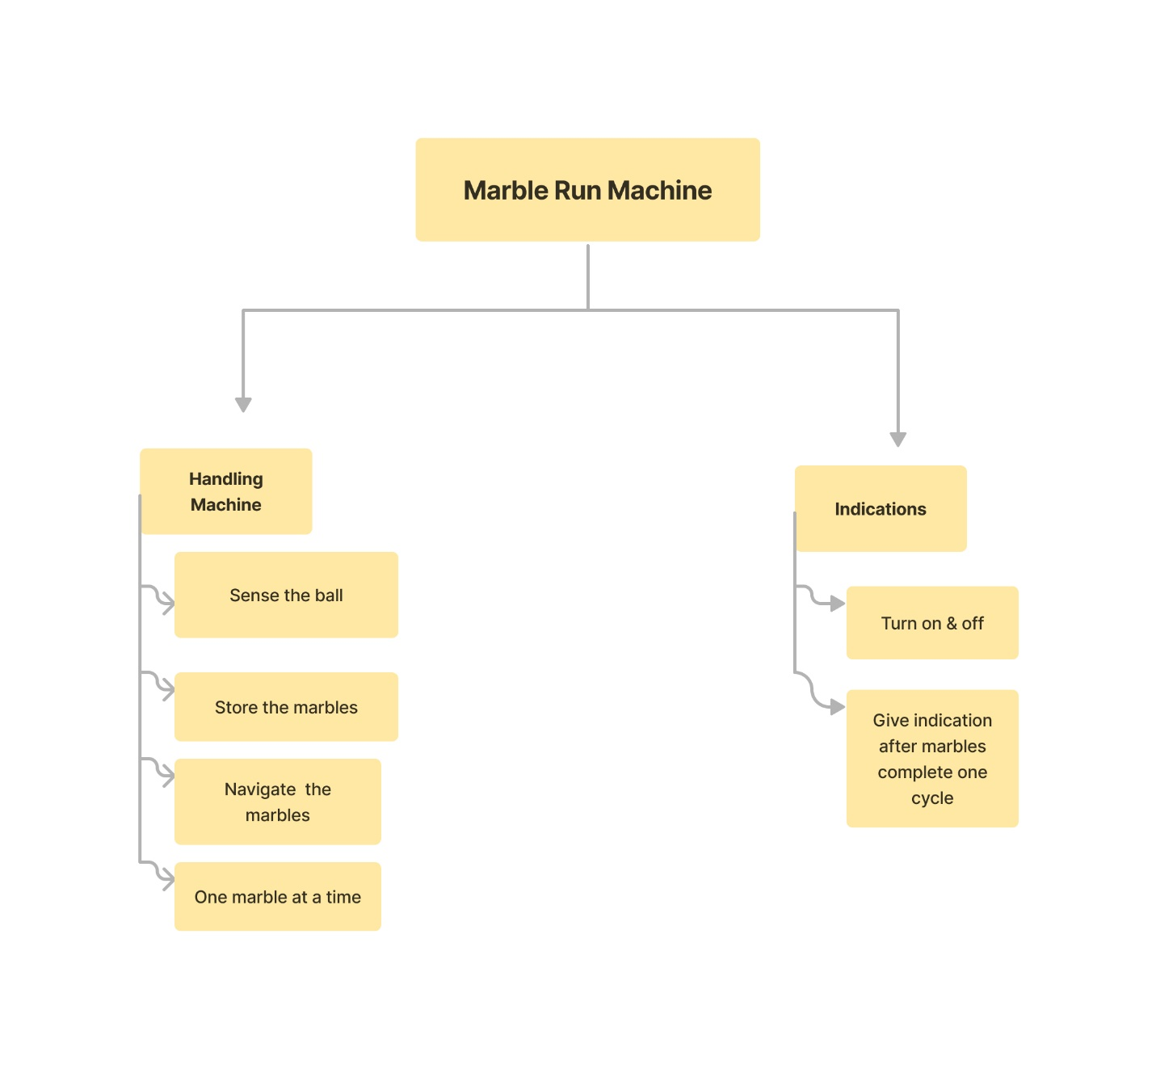

Figure 6:FUNCTION TREE

**2.3. Morphological Chart**

**Figure 7 :Morphological Chart**

|  |  |  |  |
| --- | --- | --- | --- |
| **Functions**  **Or**  **Subfunctions** | **MEAN 1** | **MEAN 2** | **MEAN 3** |
| **Indication** | **Colour Indication** | **LED** | **Buzzer** |
| **Random path of the marble** | **Default Setting** | **Sensor** |  |
| **Stop the movement of the bot** | **Voice Sensor** | **Remote Controller** | **switch** |
| **Movement of the marble in different direction** | **Spherical** | **Rotating Disc** |  |

**2.4. Generated Concepts**

|  |  |
| --- | --- |
| **Concept 1**    Figure 8:MARBLE RUN MACHINE[1] | Concept 3   Figure 9:MARBLE CLIMBING MACHINE [3] |
| **Concept 2**    Figure 10:AUTOMATIC MARBLE RUN MACHINE[2] | **Concept 4**  Figure 11:AUTOMATED MARBLE RUN MACHINE[4] |

**3. Conceptual Evaluation and Product Architecture**

**3.1. Pugh Chart**

|  |  |  |
| --- | --- | --- |
| **Sl no.** | **objectives** | **weights** |
| 1 | Safety | 9 |
| 2 | ease of use | 7 |
| 3 | portability | 6 |
| 4 | use of standard parts | 8 |
| 5 | durability | 6 |
| 6 | complexity | 5 |
| 7 | Cost | 9 |

|  |  |  |  |  |  |
| --- | --- | --- | --- | --- | --- |
| **Objectives** | **Weights** | **DESIGN 1** | **DESIGN 2** | **DESIGN 3** | **DESIGN 4** |
| 1 | 9 | + | - | ++ | DATUM |
| 2 | 7 | - | + | ++ | DATUM |
| 3 | 6 | - | + | + | DATUM |
| 4 | 8 | ++ | - | - | DATUM |
| 5 | 6 | - | ++ | + | DATUM |
| 6 | 5 | -- | + | + | DATUM |
| 7 | 9 | - | + | ++ | DATUM |
| SCORES | 50 | 7 | 22 | 59 | 0 |

**3.2. Justification for the Scores**

|  |  |  |  |
| --- | --- | --- | --- |
| **Design no** | **Objective** | **Score allocated** | **Justification of score** |
| 1 | safety | 9 | Due to the presence of motor, it has to be taken care |
|  | Ease of use | -7 | It is not easy to operate |
|  | Portability | -6 | Cannot be easily moved from one place to another |
|  | Use of standard parts | 16 | Standard use of parts |
|  | Durability | -6 | Since it is made up of cardboard it is not durable as expexted |
|  | Complexity | -10 | It is on a Complex level |
|  | COST | 9 | Model cannot be on a resonable price |
| 2 | Safety | -9 | Due to the presence of motor it has to be taken care |
|  | Ease of use | 7 | It is easy to operate |
|  | Portability | 6 | Can be moved easily from one place to another |
|  | Use of standard parts | -8 | No standard parts used |
|  | Durability | 12 | Since less cardboard it is durable as expected |
|  | Complexity | 5 | It not so complex |
|  | cost | 9 | Model can be built at a reasonable price |
| 3 | Safety | 18 | Since there is motor in a model it has to be taken care |
|  | Ease of use | 14 | It is easy to operate |
|  | Portability | 6 | It is easy to carry and operate |
|  | Use of standard parts | -8 | No standard parts |
|  | Durability | 6 | Since it made of cardboard it is not durable as expected |
|  | Complexity | 5 | It is on a moderate level |
|  | Cost | 18 | Price of the component is reasonable |
| 4 | Safety | Datum | - |
|  | Ease of use | Datum | - |
|  | Portability | Datum | - |
|  | Use of standard parts | Datum | - |
|  | Durability | Datum | - |
|  | Complexility | Datum | - |
|  | Cost | Datum | - |

## 3.3 Selected Design

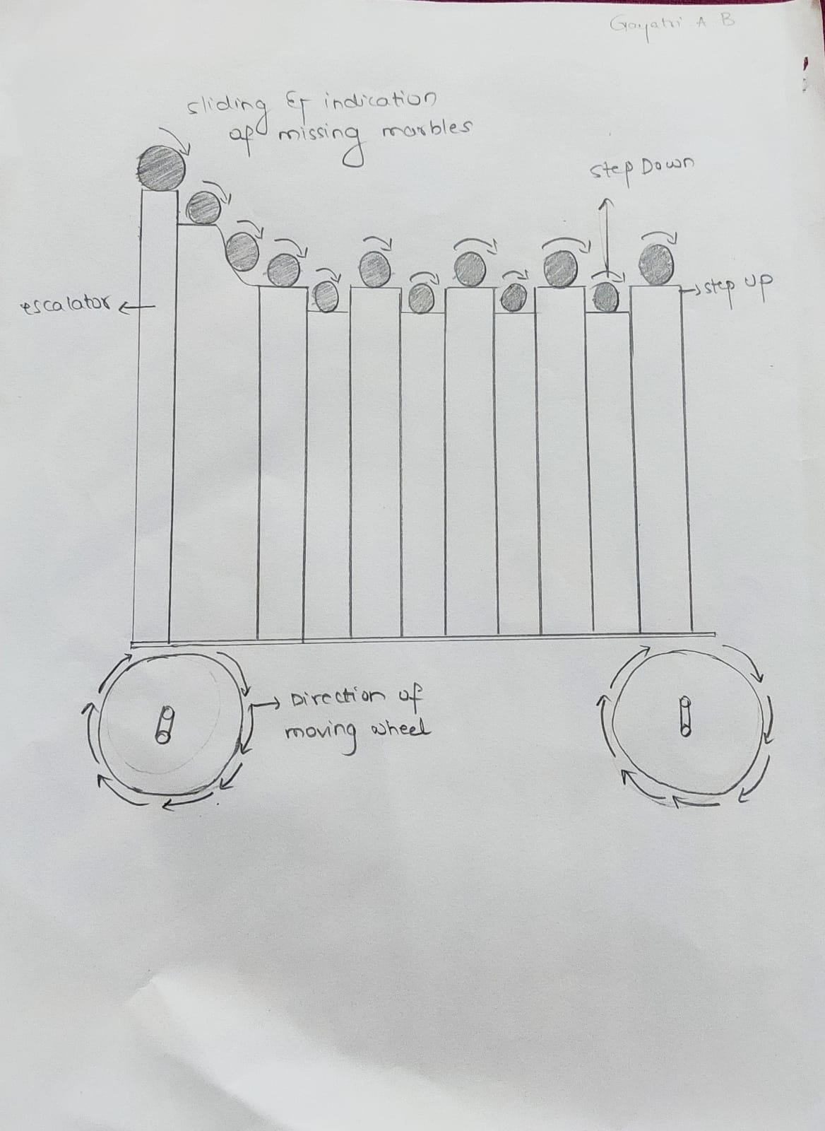

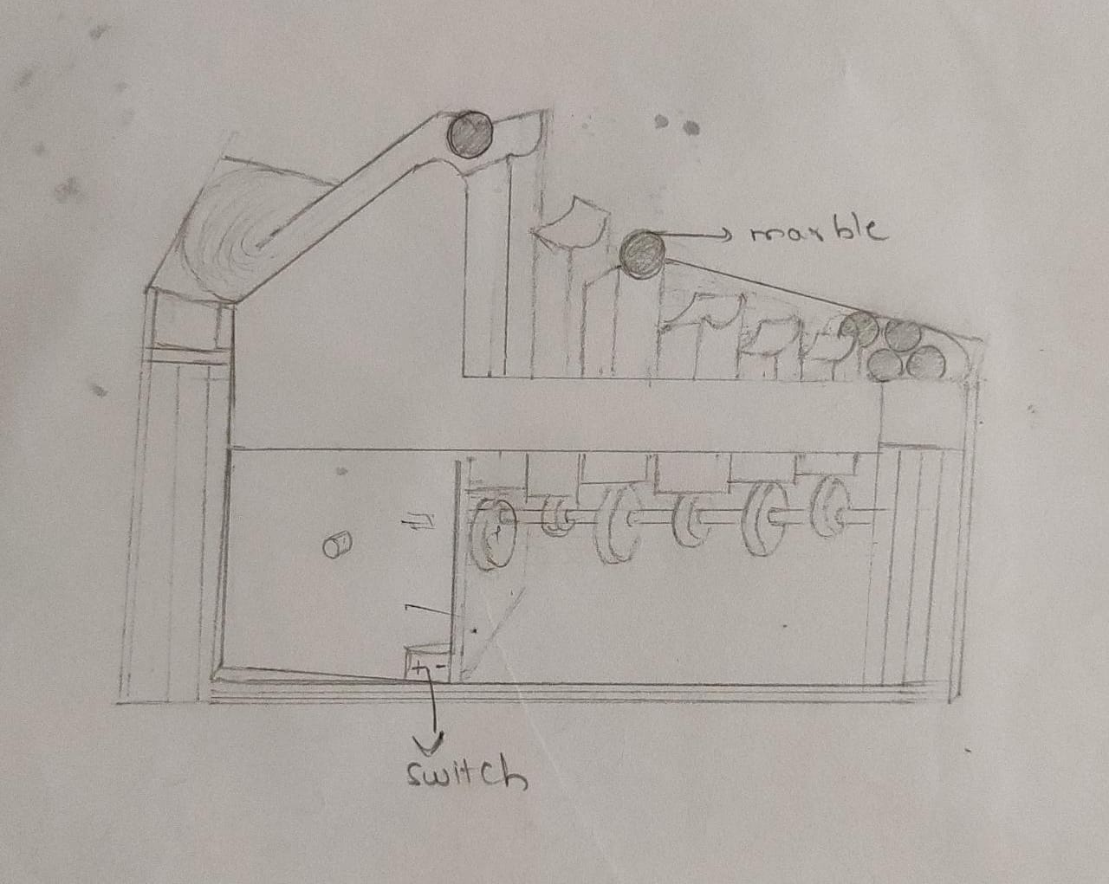

Figure 12:MARBLE CLIMBING MACHINE

## 3.4 Product Architecture

**3.4.1 Function Clustering**

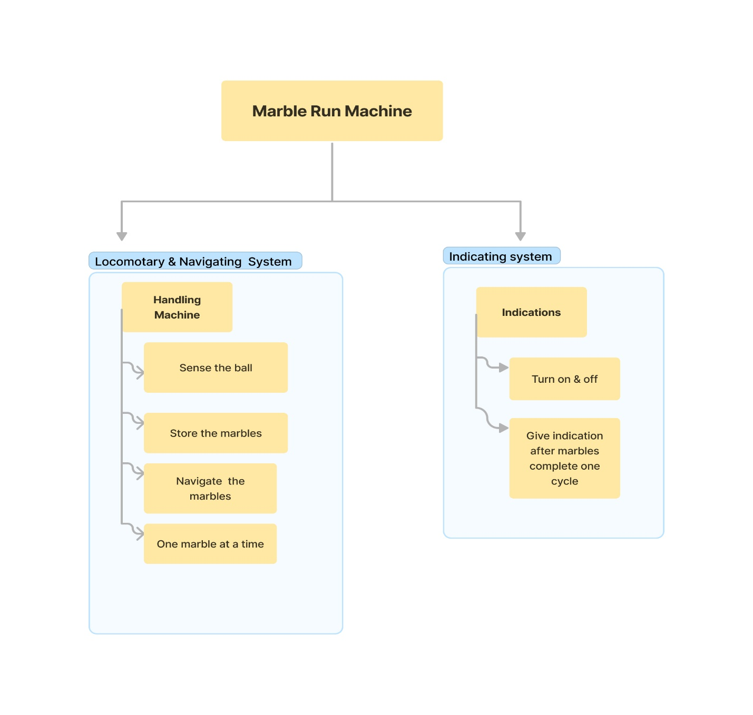

Figure 13:FUNCTION CLUSTERING

**3.4.2 Interaction between subsystems**

|  |  |  |  |
| --- | --- | --- | --- |
|  | Locomotory & Navigating System | Sensing System | Indication System |
|  | Material Interaction | X | X |
| Data Interaction | ✓ | ✓ |
| Spatial Interaction | X | X |

|  |  |  |  |
| --- | --- | --- | --- |
|  | Indication System | Locomotory & Navigating System | Sensing System |
|  | Material Interaction | ✓ | X |
| Data Interaction | X | X |
| Spatial Interaction | ✓ | X |

|  |  |  |  |
| --- | --- | --- | --- |
|  | Sensing System | Locomotory & Navigating System | Indication System |
|  | Material Interaction | X | X |
| Data Interaction | ✓ | ✓ |
| Spatial Interaction | X | ✓ |

## 4. Implementation

## 4.1. Sprint 1 Implementation

## 4.1.1. 3D model of the sprint 1 subsystem

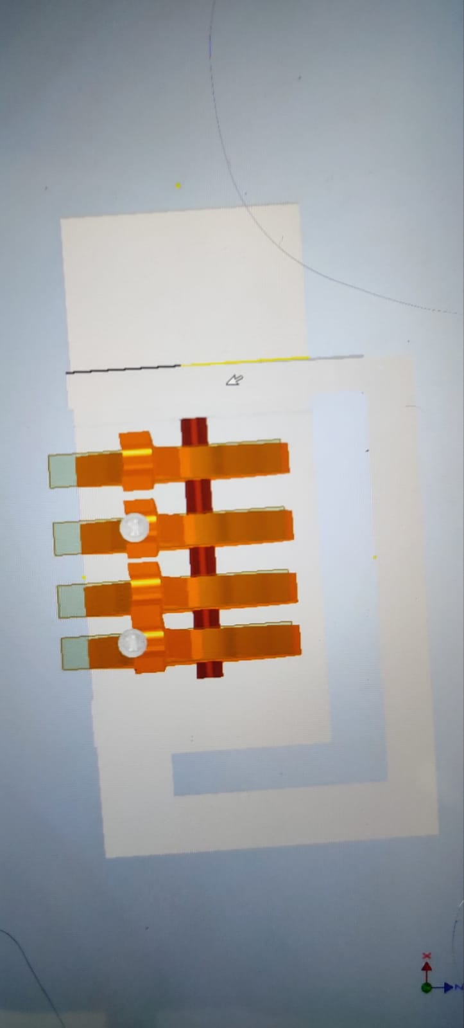

Figure 14: 3D MODEL SPRINT 1

## 4.1.2. Bill of Materials (BOM) of the sprint 1

|  |  |  |  |  |  |
| --- | --- | --- | --- | --- | --- |
| SL.NO | SPRINT NO | DATE | TIME | NAME OF THE CONSUMABLE | SPECIFICATION & QUANTITY |
| 1 | 1 | 11/7/2022 | 11:10 | Nylon rod (10mm,15 cm) | 1 |
| 2 | 1 | 11/7/2022 | 11:10 | Aluminium square rod(10 mm,length-10cm,breadth-2.7cm) | 5 pieces |
| 3 | 1 | 11/7/2022 | 11:10 | Cam Acrylic Sheet (5 mm) | 5 pieces |
| 4 | 1 | 13/7/2022 | 12:45 | Foam Sheet(10 mm) | 1 |

## 4.1.4. Flow chart of the sprint 1

## 

Figure 15:FLOW CHART 1

## 4.1.5. Physical implementation image of the sprint 1

Figure 16:PHYSICAL IMPLEMENTATION SPRINT 1

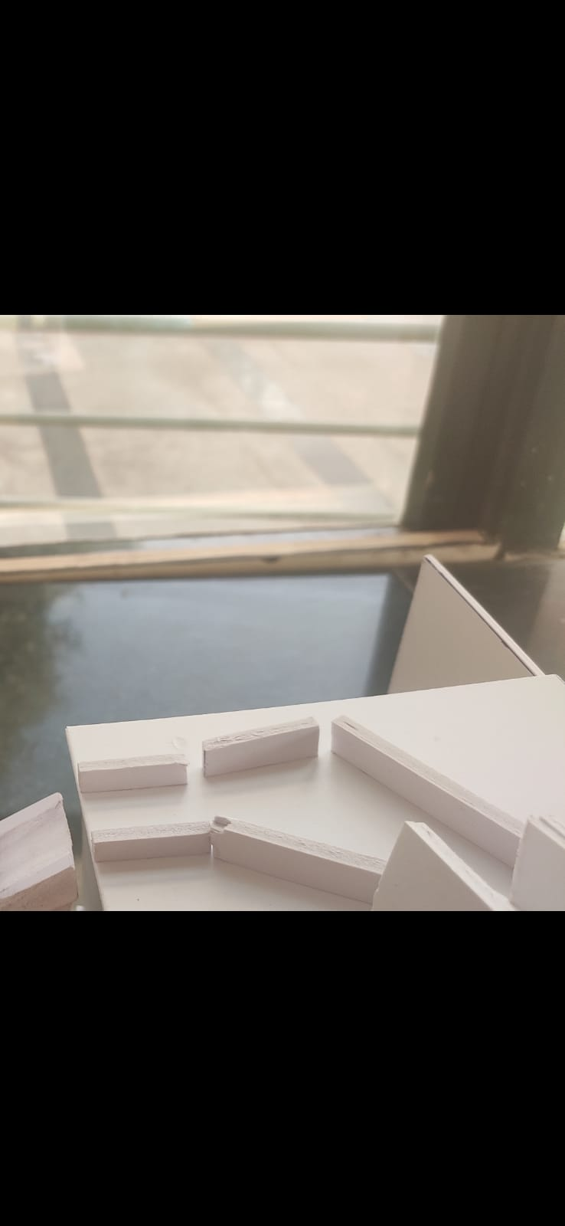

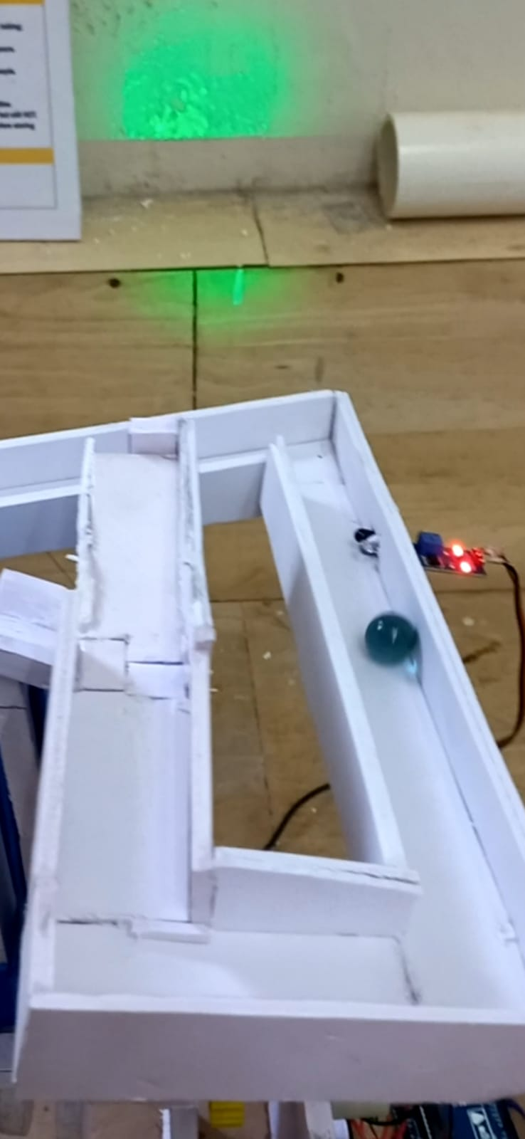

## 

## 4.2. Sprint 2 Implementation

## 4.2.1. 3D model of the sprint 2

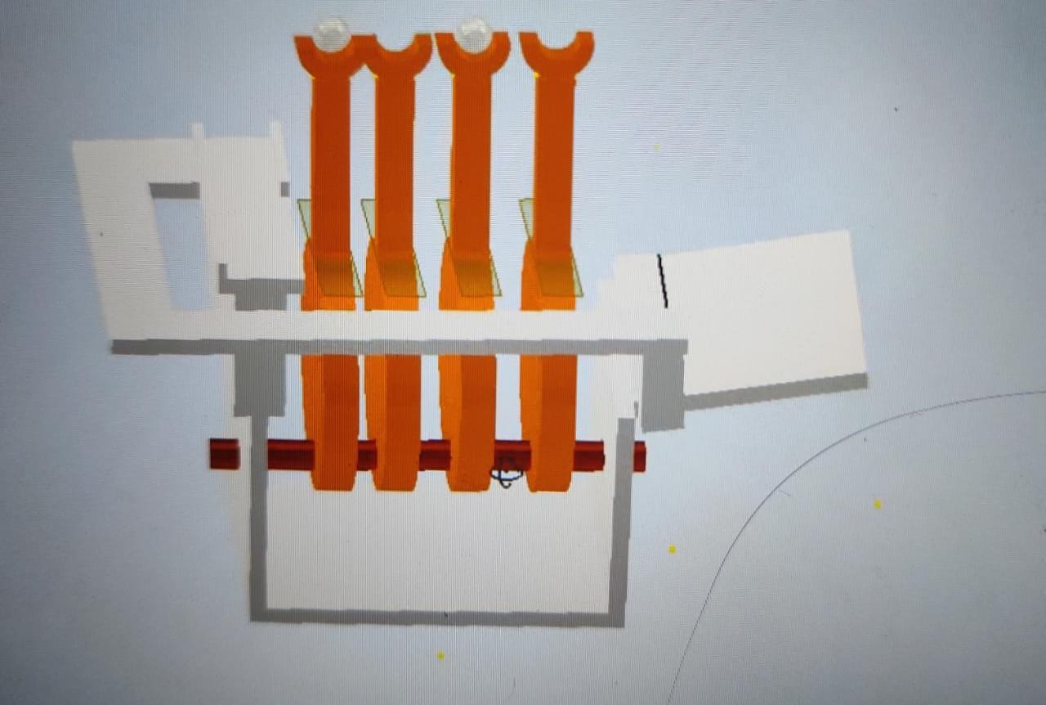

Figure 17:3D MODEL SPRINT 2



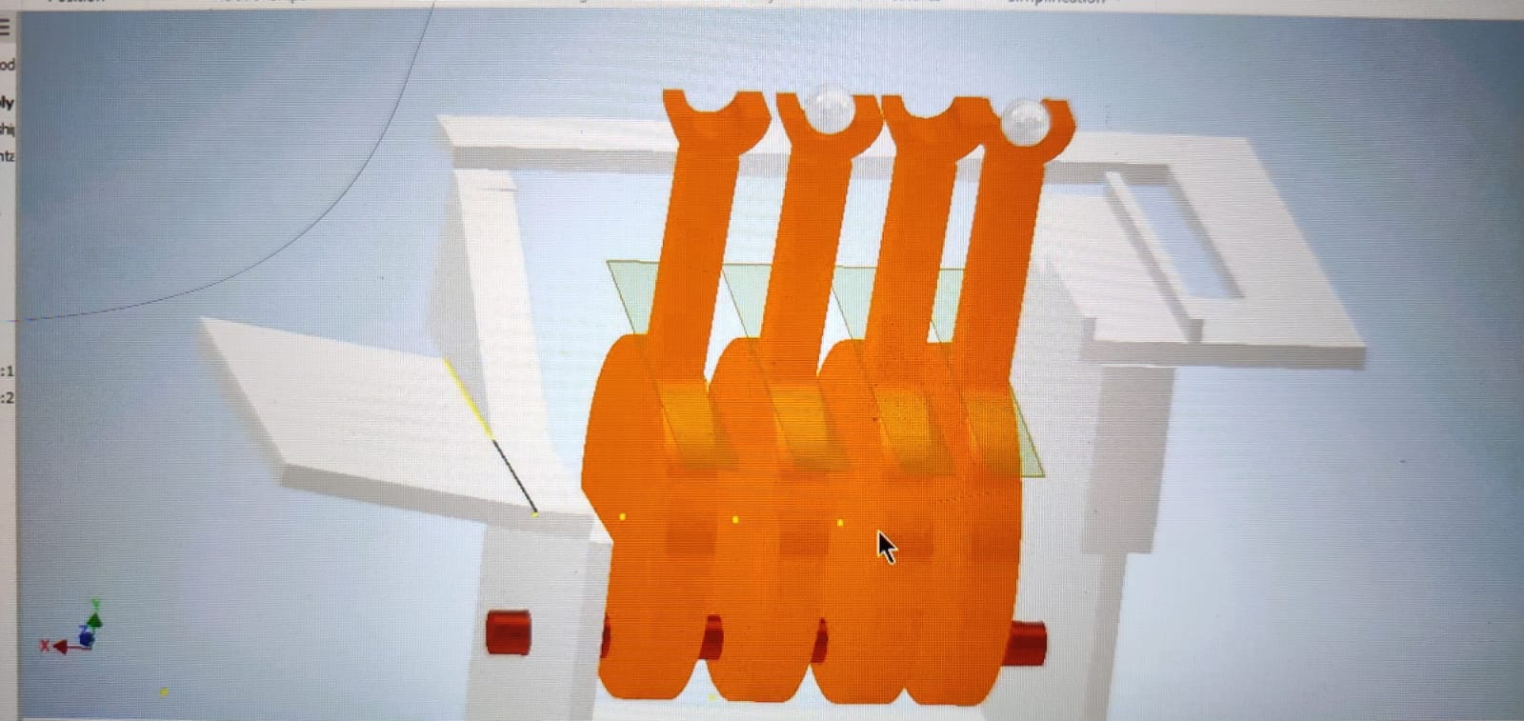

## 4.2.2. Bill of Materials (BOM) of the sprint 2

|  |  |  |  |  |  |
| --- | --- | --- | --- | --- | --- |
| SL.NO | SPRINT NO | DATE | TIME | NAME OF THE CONSUMABLE | SPECIFICATION & QUANTITY |
| 1 | 2 | 13/7/2022 | 12:45 | Foam Sheet (10 mm) | 1 |
| 2 | 2 | 15/7/2022 | 1:15 | Foam Sheet (10 mm) | 1 |
| 3 | 2 | 15/7/2022 | 2:35 | Cam Acrylic Sheet(3 mm) | 10 pieces |
| 4 | 2 | 15/7/2022 | 3:00 | Nuts and Bolts(4 mm) | 40 |

## 4.2.3. Circuit diagram of the sprint

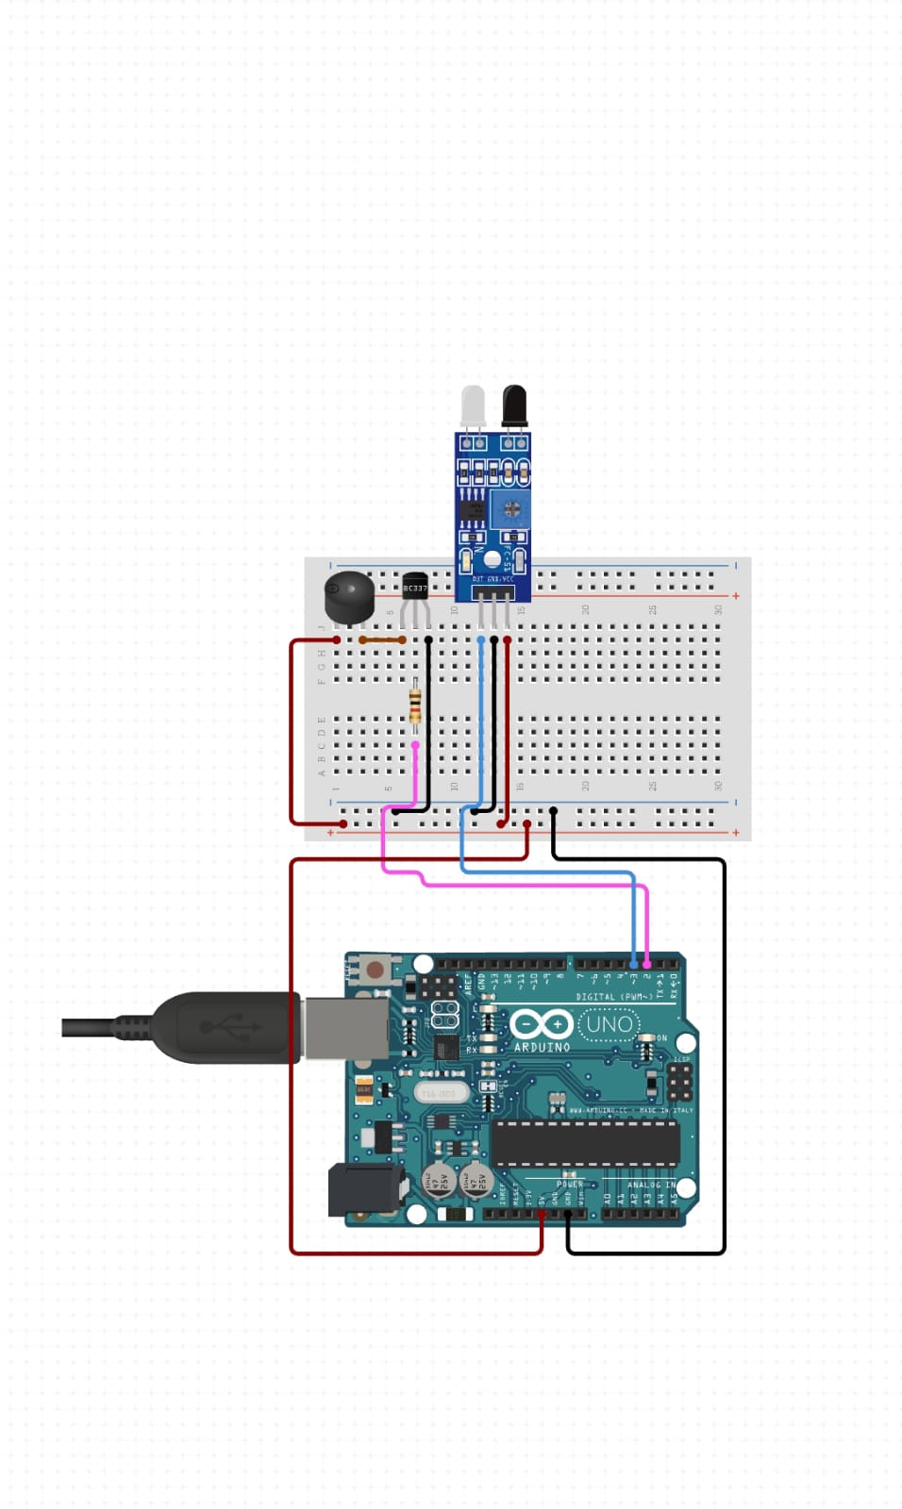

Figure 18:CIRCUIT DIAGRAM

## 4.2.4. Flow chart of the sprint 2

## 

Figure 19:SPRINT 2 FLOW CHART

## 4.2.5. Physical implementation image of the sprint 2

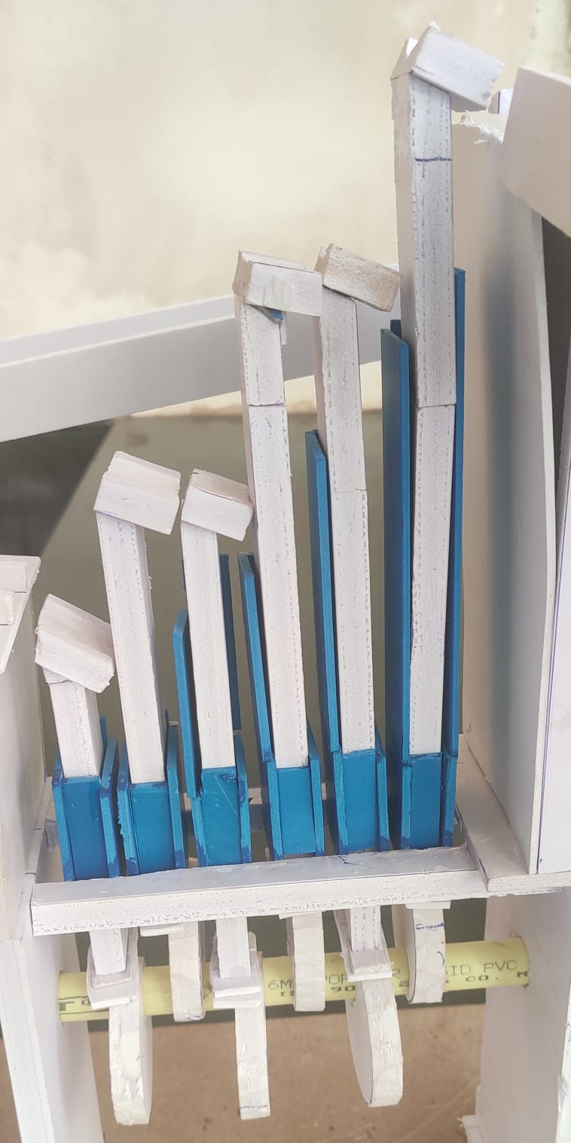

Figure 20:PHYSICAL IMPLEMENTATION SPRINT 2

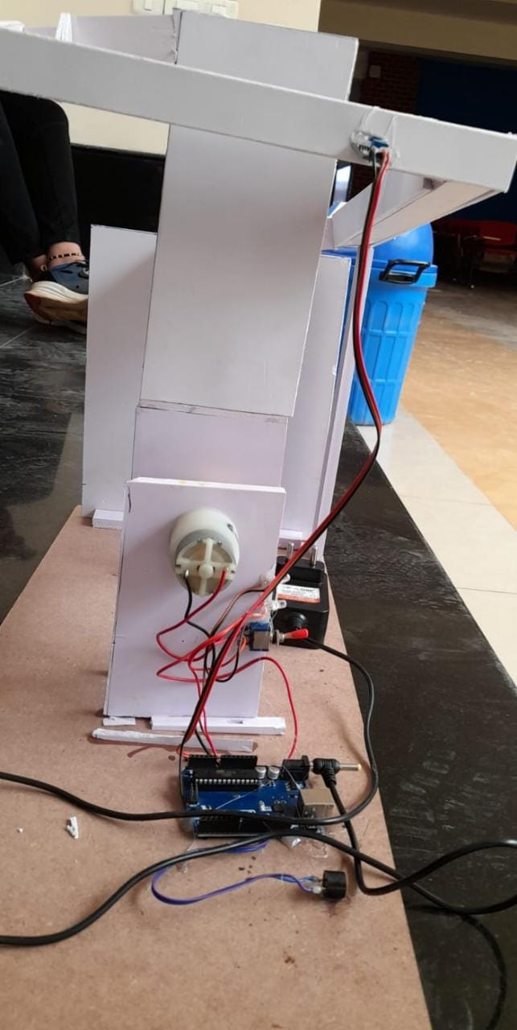

**FINAL MODEL:**

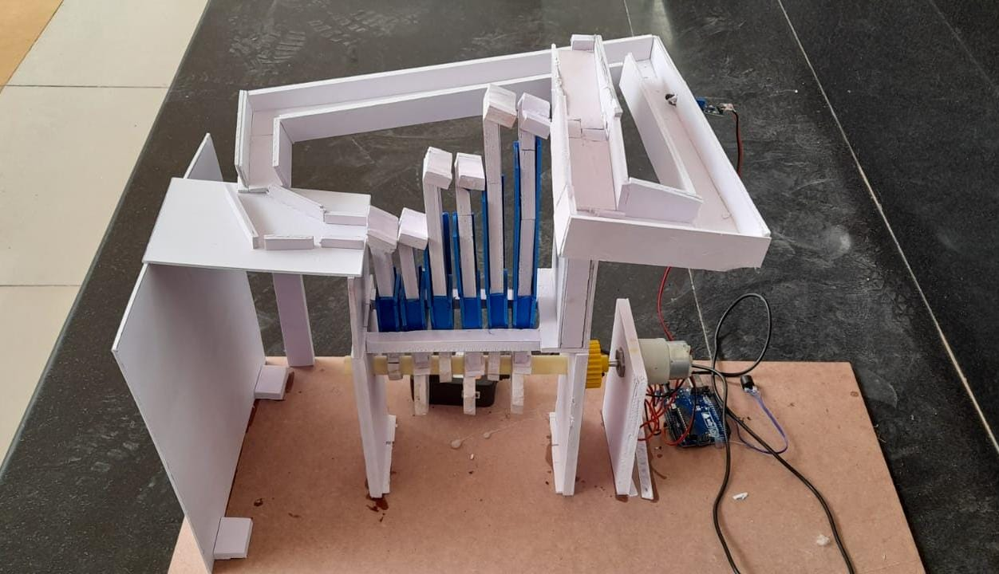

## 4.3.MOTOR AND RESOURCE SPECIFICATION

## Motor Sizing

* Total Mass=150
* Radius=r=1CM
* Force=6.5
* Torque=1509.81=1.47KG/CM

### 60 RPM Motor At 12V

## Battery Sizing

| **Sl No.** | **Components** | **Voltage** | **Current** |
| --- | --- | --- | --- |
| 1. | Arduino Mega | 12V | 100mA |
| 2. | IR Sensor | 5V | 15mA |
| 3. | DC Motor(60rpm) | 12V | 350mA |
| 4. | Buzzer | 12V | 2 A |

* For 12V Voltage Current is 510mA
* For 5V Voltage Current
* Factor of Safety(FOS) = 1.2
* For 12V Voltage Current is 612mA
* For 5V Voltage Current is 18mA

## 5. Statement of Expenditure

|  |  |  |  |
| --- | --- | --- | --- |
| Sl. No | Item with description | Quantity | Price in Rs. |
| 1 | DC Motor (60 RPM) | 1 | ₹200 |
| 2 | DC Motor (30 RPM) | 1 | ₹190 |
| 3 | Marbles | 10 | ₹50 |
| 4 | Black spray | 1 | ₹290 |
| 5 | Arduino UNO | 1 | ₹1000 |
| 6 | Gear | 1 | ₹100 |
| 7 | Switch | 1 | ₹20 |
| 8 | Foam sheet 10 mm | 1 | ₹250 |
| Total | | | ₹2100 |

**6. Future Scope:**

* In future there will be more scope for the user controlled bot.
* The speed of the bot can be controlled which will make it more efficient while moving.
* The mechanism used in this bot can be used in paper cutting machines and the weaving textile machinery.
* More functions can be added to the bot like the music system and to count the marbles and display it after each lap .

**7.References:**

1]<https://www.sentex.ca/~mwandel/marbles/machine1.html>

2]<https://www.behance.net/gallery/36018301/Mechanism-Project-Marble-Machine>

3]https://www.meleeproductions.com/marble-machine

4]<https://www.instructables.com/Make-a-Marble-Machines-board/>

5]<https://www.sciencebuddies.org/science-fair-projects/project-ideas/ApMech_p051/mechanical-engineering/marble-machine>

6]<https://www.exploratorium.edu/tinkering/projects/marble-machines>

7]https://www.instructables.com/Wooden-Marble-Roller-Machine/